Linux Security Compliance Scanner
M BHAVYA TEJASWI SHASHIDHAR
CYBER SECURITY CYBER SECURITY MENTOR
TAH1702262005 TEKS ACADEMY
TEKS ACADEMY 9603343287
7330810326
Abstract:
• Linux Security Compliance Scanner is a Bash-based security tool that audits the Linux
operating system and identifies common security misconfigurations.
• Modern computer systems face various configuration issues that put the system at risk of
being compromised. The issues include open ports, insecure file permissions, weak password management, disabled firewalls, and outdated packages.
• The main goal of the project is to automate the identification of common security
weaknesses using Linux system commands.
• The scanner carries out a number of security checks, including system information checks,
user account checks, checking the permissions of critical files, checking the status of the firewall, checking the SSH security configuration, checking the password policy, and
checking for system updates.
• The tool provides a security report that lists the security vulnerabilities. It also provides a
security compliance score that shows the security posture of the system.
• The security scanning tool helps the system administrator by automating the security
checks. It helps the system administrator to easily identify the security vulnerabilities on
the system.
• The project helps the students to understand the internal working of Linux security
auditing tools. It gives the students exposure to Linux system administration and security
concepts.
• The programming languages and Linux system commands used are Bash scripting and the
Linux system commands ss, grep, awk, systemctl, ufw, and apt.
• The main objective of the project is to enhance the security awareness of the system. It
helps the system administrator to implement security compliance scanning using scripting techniques.
2. Problem Statement
• Many Linux systems are deployed with default configurations that may not follow
security best practices.
• Administrators often overlook important security settings such as firewall rules, password
policies, SSH configurations, and file permissions.
• Attackers commonly exploit misconfigured systems to gain unauthorized access, escalate
privileges, or execute malicious activities.
• Manual security auditing is time-consuming and requires deep knowledge of system
configuration files and security standards.
• System administrators must check multiple files and services such as /etc/shadow,
/etc/ssh/sshd_config, /etc/login.defs, firewall rules, and running services.
• Without automated tools, it becomes difficult to maintain consistent security checks
across multiple systems.
• A lot of businesses use security auditing tools to make sure they follow security standards
and best practices.
• Cybersecurity professionals need to know how these tools work on the inside, though.
In Simple Terms
• To keep attackers from getting into Linux computers, they need to be set up with the right
security settings.
• System files and configuration files hide many security settings.
• It takes a lot of time and effort to check all of these settings by hand.
• The Linux Security Compliance Scanner automates these checks and analyzes system
security.
• The scanner runs several commands and verifies system configuration files.
• It checks whether the firewall is active, whether sensitive files are protected, and whether
password policies are strong.
• It also checks if there are open ports that may expose services to attackers.
• The tool then generates a report showing security issues and improvements needed.
• In simple words, this project acts like a health checkup tool for Linux security.
The Solution: Why we Need an Automated Fix
• Security misconfigurations are one of the most common causes of system vulnerabilities.
• Manual inspection of security settings can be inconsistent and prone to human error.
• Automated tools make sure that every system is evaluated using the same security checks.
• The Linux Security Compliance Scanner automates the process of checking system
security configurations.
• The tool performs multiple checks in a structured and repeatable way.
• Automation cuts down the time needed for system security audits.
• It helps administrators quickly spot issues like weak password policies, open ports, and
insecure SSH settings.
• Automated scanning also allows for regular security assessments to keep up with security
standards.
• By providing a security score and report, the scanner helps administrators focus on
security improvements.

3. Project Objectives
• To develop and design a Linux security compliance scanning tool.
• To automate various Linux security audits using Bash scripting.
• To identify various security misconfigurations that could lead to system vulnerabilities.
• To increase knowledge about Linux system administration and security mechanisms.
• To analyze critical system configuration files related to authentication and network
security mechanisms.
• To develop and design various security checks related to the configuration of the firewall,
ports, SSH, and password policy.
• To develop and design a structured security report that identifies various system
vulnerabilities.
• To develop and design a security score that reflects the compliance of the system with
various security best practices.
• To showcase various cybersecurity skills by implementing a real-life security audit
project.
4. Project Scope
• The project is about conducting security audits on Linux-based systems.
• It examines the system's configuration files, services, and network settings.
• The tool is intended for local security auditing instead of network scanning.
• The project provides a demonstration of how security scanning can be automated through
the use of a Bash scripting technique.
• It covers all the security aspects of the system, including the security of the users, files,
firewalls, SSH, and updates.
• It is possible to execute the tool on a Linux platform running Kali Linux, Ubuntu, or Debian.
• The project gives a glimpse into how security auditing tools are implemented by experts.

What's Not Included
• The project does not include exploitation of vulnerabilities or penetration testing.
• It does not include scanning of external networks or systems.
• It does not include automatic exploitation of detected vulnerabilities.
• Advanced vulnerability databases or CVE detection are not supported.
• It does not include graphical user interface or web interface.
• It does not include real-time monitoring or intrusion detection.
• It only focuses on configuration-based security checks and does not include a full-scale
vulnerability assessment.
Key Requirements & Assumptions
• The system running the scanner must be a Linux-based operating system.
• The user executing the scanner should have administrative privileges.
• Standard Linux utilities such as ss, grep, awk, systemctl, and ufw should be installed.
• The scanner assumes that configuration files such as /etc/login.defs and
/etc/ssh/sshd_config are present in standard locations.
• The system must allow access to firewall and system service information.
• The tool assumes that system updates are managed through the APT package manager.
What You'll Get
By the end of this project, we'll deliver a complete package:
• A Linux security compliance scanner that works perfectly with Bash.
• Checking the security of important system settings automatically.
• Finding common security settings that are wrong.
• Finding open ports and services that are running.
• Check the status of the firewall and the security settings for SSH.
• Check the password policy and system updates.
• A security report that was made with the results of the compliance check.
• A score that shows how secure the system is overall.
5. Tools and Technologies Used
To build this automatic security patch script, we're using a collection of powerful tools that are all part of the Linux environment. Here's a simple breakdown of our toolkit and why each piece is so important:
- Kali Linux: This is our home base. We're using Kali because it's specifically designed for cybersecurity and its foundation on Debian makes managing software and updates with APT a smooth process.
- APT (Advanced Package Tool): Think of APT as the system's go-to delivery service for software. We use it to automatically find and install all the necessary security patches. It's the command that does the heavy lifting, running a command like sudo apt update && sudo apt upgrade -y in the background.
- Bash (Bourne Again Shell): We're writing the script itself in Bash. It’s the perfect scripting language for automating system tasks because it’s simple, powerful, and built into Linux.
- Important Linux tools used:
• ss – to find open network ports
• grep lets you search through configuration files.
• systemctl is used to manage and check system services.
• ufw – for checking firewall status
• apt – for checking system updates
In a nutshell:
- Kali Linux: Our operating system.
- APT: The tool that handles all the updates.
- Bash: The language we write the script in.
- Nano/Vim: What we use to write the code.
7. Deliverables
The deliverables are the final pieces you'll have once the project is finished. They're the concrete things you can show, use, and share to prove the project is complete and working. For this project, here's what you'll get:
i) The Main Script
• The main deliverable is the Bash script that performs the security compliance scan.
• The script runs multiple security checks and creates the final report.
• It is the main part of the project.
ii) The Schedule
• There is a defined schedule for running the scanner regularly.
• The scanner can be set up to run using cron jobs.
• Scheduled scans help maintain ongoing security monitoring.
iii) The Record
• The scanner creates a security report file.
• This report includes the results of all security checks.
• It documents the system's security status for review and auditing.
iv) The Guide
• Documentation shows how to install, configure, and run the scanner.
• There are step-by-step instructions for running the script.
• It describes each security check that has been implemented.
v) The Presentation
• A presentation explains the project goals, design, and results.
• It shows how the scanner works and what security checks it performs.
• This is useful for project demonstrations, academic submissions.

8. Project Implementation
Step 1. Create a Bash Script
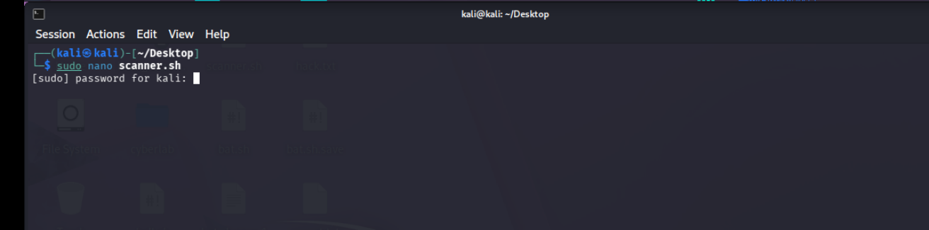

Code:
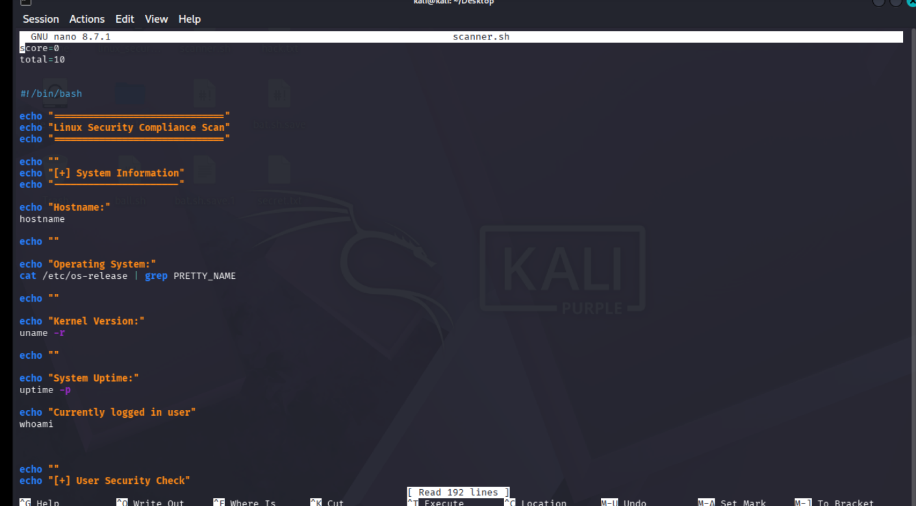

Step 2: Make the script executable
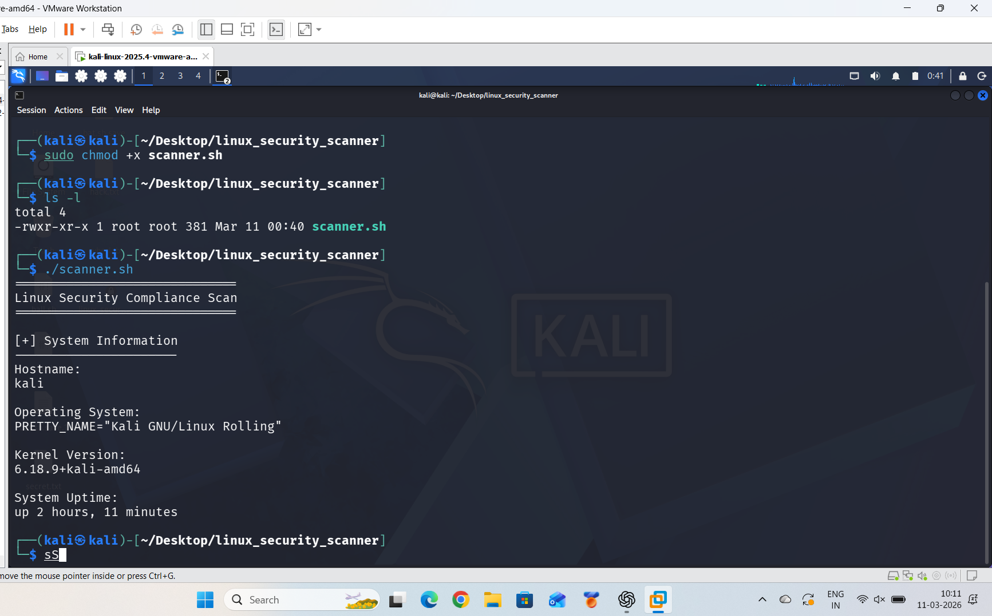

Step 3: Firewall status check
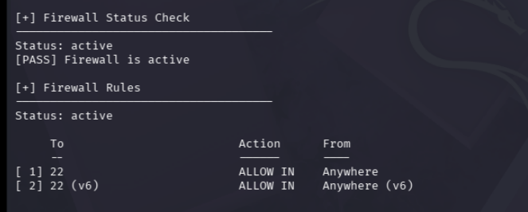

Step 4: Password policy check
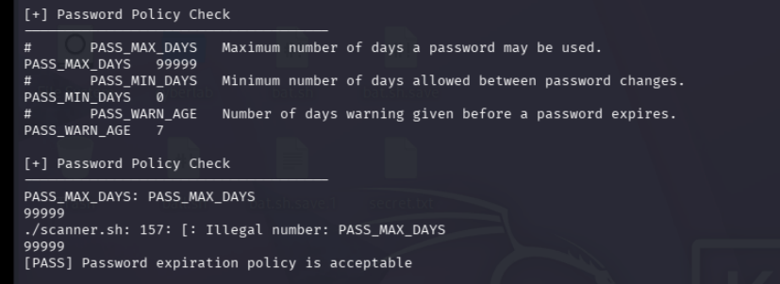

Step 5: System Update Check
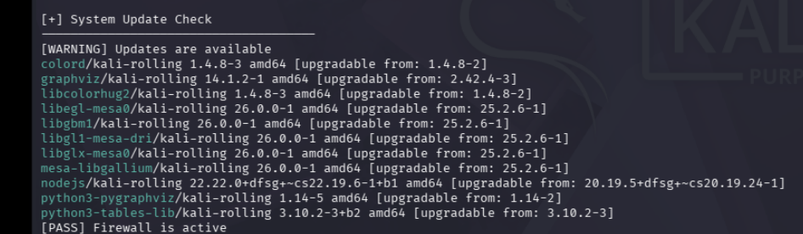
Step 6: Compliance score
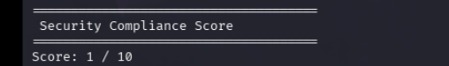

Conclusion
• The Linux Security Compliance Scanner shows how to use Bash scripting and Linux
tools to automate system security auditing.
• The project shows how important it is to find configuration-based vulnerabilities in
Linux systems.
• Automated scanning makes security auditing easier and raises awareness of system
security.
• The scanner helps administrators find problems like weak password policies, SSH
configurations that aren't secure, and updates that are missing.
• The security report that was made gives useful information that can be used to make the
system more secure.
• This project gives you hands-on experience with Linux security and system
administration.
• It also shows how professional security auditing tools work on the inside.
• The project is a starting point for making better cybersecurity tools in the future.

